Pacemakers

What is a Pacemaker?
A Pacemaker is a small electronic device, which increase the heart rate in people who have a slow heart rhythm (bradycardia). A pacemaker consists of a pulse generator (’box’) which contains the battery and electronics and leads (wires) which connects the generator to the heart.

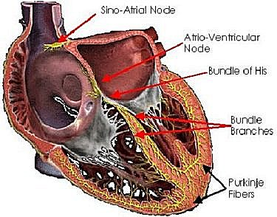
When is a Pacemaker needed?
In the normal heart, the heart muscle contracts due to a small electrical current produced by a collection of special cells (Sino-Atrial Node) which are situated in the top chamber (atrium) of the heart. These impulses travel along the atria but cannot directly go into the bottom chambers (Ventricles or pumping chambers) because there is a fibrous non-conducting tissue between them. The only way it can travel is through a special conducting system (wiring) called the Atrio-Ventricular Node and HIS bundle. Eventually the impulses reach the ventricular muscle cells through the Purkinje Fibers. Slow heart rate can be caused by disease in the Sinus node (called Sick Sinus Syndrome) or AV node and HIS bundle (called Complete Heart Block). People who have these conditions may feel dizzy and faint, have breathlessness and confusion particularly in the elderly. Rarely they can present with strokes. Sick Sinus Syndrome (SSS) and Complete Heart Block (CHB) cannot be properly treated by drugs. Therefore these patients need a pacemaker implantation which effectively cures the problem.

How are these conditions caused?
Both SSS and CHB are conditions seen more often in older people and is due to degeneration of these cells and tissues like any other in the body. These can also occur after a heart attack and sometimes after heart surgery. Sometimes, particularly CHB, is seen at birth and then the condition is called Congenital CHB. Some babies have a reasonable heart rate (50 – 60 beats per minute) and if their growth and development is normal, heart size is normal (assessed by an Echocardiogram) and they have no symptoms (lethargy, increased sleepiness, fainting) pacemaker implantation can be delayed until they are bigger. This is because in very small babies pacemaker implantation has to be done by opening the chest as the generator and leads are too big. However pacemaker implantation has been successfully done in babies as small as 3 months old. In bigger children pacemaker implantation can be done like in adults. SSS can also occur in children and young adults but is rarer in this age group.

How are these conditions diagnosed?
If a patient complains of some of the symptoms mentioned above a doctor might suspect that the patient has some type of bradycardia. The doctor might notice that the patient’s pulse rate is slow. An ECG will very often provide the diagnosis. If not special tests such as Holter monitoring (24 hour ECGs) and Electrophysiological tests (a test carried out by inserting a special catheter into the heart through a vein) may be needed to confirm the diagnosis. Occasionally in patients who do not have many symptoms, these conditions may be found when doing routine ECGs for medical check ups etc. In babies, congenital heart block is detected usually at birth or at the first routine visit to the doctor.

Are there different types of pacemakers?
Yes. Basically there are 2 types of pacemakers, single chamber and dual chamber. Single chamber pacemakers are the simplest type of pacemakers and pace only one chamber of the heart. Dual chamber pacemakers are more sophisticated and pace both the top (atrium) and bottom (Ventricle) chamber. Dual chamber pacemakers maintain the normal relationship between the top and bottom chambers and provide a better quality of life. The cost of dual chamber pacemakers tend to be twice as much as single chamber pacemakers.

How is a pacemaker implanted?
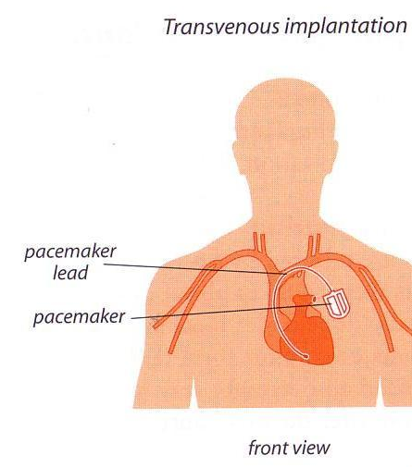
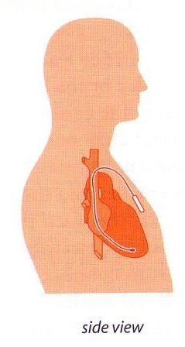
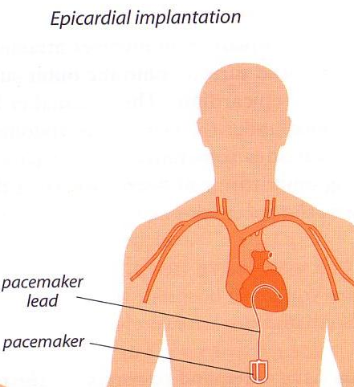
As mentioned earlier a pacemaker has a generator (the ‘box’) and lead/s. For the pacemaker to function, one end of the lead must touch the heart muscle. Generally the lead is introduced into the heart through a trans-venous approach. This procedure is usually done under a local anaesthetic and takes about 1 – 1¹/₂ hours. The lead (or two leads in the case of a dual chamber pacemaker) is inserted through a vein at the level of the shoulder and positioned in the Right Ventricle (bottom chamber). If a dual chamber pacemaker is used the second lead is positioned in the Right atrium (top chamber). A ‘pocket’ is fashioned under the skin in front of the shoulder (left if patient is right handed or right if patient is left handed) and the box is placed in this pocket. Patient can generally go home in 2 -3 days and by about one week the wound is completely healed. Unless the patient is very thin, the pacemaker (which is about 3-4 cm in diameter and a few mm in thickness) is not noticeable under the skin. In very small babies this trans-venous route is not possible as the veins are too small and there isn’t enough space in the shoulder area to place the generator. In these babies a heart surgeon opens the chest and positions the lead on the out side of the heart (epicardial) and places the generator in the stomach wall. When bigger these children can also have a trans-venous pacemaker.

What are the complications of pacemaker implantation?
Pacemaker implantation is a very safe procedure but rare complications can occur. There is a small risk of air leaking into the chest cavity (pneumothorax) while the lead is being inserted into the vein. This usually resolves on its own. Bleeding can occur into the pacemaker pocket and sometimes the wound has to be re-opened to evacuate the blood. Very rarely blood can collect around the heart (haemopericardium) due to a lead perforating the heart muscle. There is a small risk of infection, especially in patients with uncontrolled diabetes.

What happens after the implantation?
Once the patient goes home and the wound is healed, and initial programming (tuning) of the pacemaker is done in about 6 weeks after implantation. This is vital as all pacemakers come with factory settings and certain features have to be changed to suite the patient and also prolong battery life. This tuning is done using a special machine called the programmer which can ‘talk’ to the pacemaker wirelessly. Once the initial programming is done the pacemaker needs to be checked 6 to 12 monthly to make sure it is functioning normally and to detect low battery power. The pacemaker runs on a special lithium battery and most last for 8 – 10 years. Once the battery runs down the whole ‘box’ has to be replaced. Usually the old lead can be used but sometimes this too has to be replaced.

Can a person with a pacemaker lead a normal life?
Yes. Once a pacemaker is implanted a patient’s heart rhythm becomes normal. Patients can go back to a normal lifestyle and don’t even notice that hey have a pacemaker. Doctors, businessmen, dancers, sportsmen and even soldiers have gone back to continue their normal activities after pacemaker implantation.

Can household and other equipment affect the pacemaker?
Modern pacemakers are not affected by micro-wave ovens, washing machines etc. Patients with pacemakers can use computers, remote controllers and i-pods etc. quite safely. Mobile phones should be used kept at least 15 cm (6 inches) away from the pacemaker. Very high magnetic fields such as high tension wires and some high security metal detectors (in airports) can temporarily affect pacemaker function. For similar reasons MRI scans cannot be done on a patient with a pacemaker though this may change in the future as already special pacemakers have been developed which can withstand MRI scans (and have already been implanted in some patients in Sri Lanka). A patient with a pacemaker must inform other doctors specially surgeons as certain precautions need to be taken during procedures.

Is pacing done for conditions other than SSS and CHB?
Yes. In the recent years a special type of pacemaker called BiVentricular pacemakers have been implanted for patients with severe heart failure. These patients do not necessarily have slow heart rates. These pacemaker which have leads in the Right top chamber and both right and left bottom chambers (ventricles) correct an electrical dysynchrony (disorganization) which occurs in some patients with heart failure. Not all patients with heart failure are suitable for this procedure and not all will respond positively. These pacemakers are very expensive and the procedure for implantation is also more complex. Patients who respond have a greatly better quality of life, improved heart function and longer life span.

